**Project Title*: PDF Reader***

**Group Members:**

Wajahat Raza(p176011)

M. Ahmed Arshad(p176099)

Tashfeen Latif(p176099)

Muneeb Raza(p176149)

M. Hafeez Ullah(p176144)

Saood Ur Rehman(p176092)

Ahmad Hassan Hamdani(p176021)

**Client Name:**

Prof. Taimoor Khan



**Department of Computer Sciences**

**FAST National University of computer and Emerging Sciences**

**Peshawar, Pakistan October, 2019**

**Iteration#02**

**Traceability Matrix:**

|  |  |  |  |  |  |  |  |
| --- | --- | --- | --- | --- | --- | --- | --- |
| **Requirement ID** | **Basic Use Case** | **Detailed Use Case** | **Use Case**  **Diagram** | **Activity Diagram** | **Domain Model** | **Integration** | **Testing** |
| 1 | Page 3 | Page 5 | Page 12 | Page 15 | Page 18 |  |  |
| 2 | Page 3 | Page 6 | Page 13 | Page 16 | Page 18 |  |  |
| 3 | Page 3 | Page 7 | Page 14 | Page 17 | Page 18 |  |  |
| 4 | Page 3 | Page 8 |  |  |  |  |  |
| 5 | Page 3 | Page 9 |  |  |  |  |  |
| 6 | Page 3 | Page 10 |  |  |  |  |  |
| 7 | Page 3 | Page 11 |  |  |  |  |  |
| 8 | Page 3 |  |  |  |  |  |  |
| 9 | Page 3 |  |  |  |  |  |  |
| 10 | Page 3 |  |  |  |  |  |  |
| 11 | Page 4 |  |  |  |  |  |  |
| 12 | Page 4 |  |  |  |  |  |  |

**Use Case:**

1. **Displaying a pdf document:**

The user is asked for a document to read. If the extension of file is pdf then user will be able to see the file.

1. **Highlighting a sentence:**

If the user finds something important information about a point or a sentence. He can easily highlight them so that they may be use in future.

1. **Jumping to the desired page:**

The user can easily jump to desire page by typing the page number that he want to visit. If the number is in desire range then it will be displayed.

1. **Maintain notes on some specific words**:

User will select a specific word or sentence on which user wants notes. After selecting that word or sentence he will be able to add notes.

1. **Share a pdf:**

User will be able to share documents by giving email address of the person he wants to share document with.

1. **Find and Replace**:

User will enter a word to replace. After the word is successfully found user will enter another word by which the word is to be replaced.

1. **Add a password on a document**:

To keep pdf private user will be given an option to protect its document by setting a password. On provision of the correct password the user is allowed save pdf in private mode.

1. **View meaning of a word:**

In this pdf reader there is an option for a user to find the meaning of particular word instead search online.

1. **Save Bookmarks for a document:**

If the user wants to open a pdf from where he closed. Before closing a pdf the user make bookmark so that he used this bookmark to open a document where he closed last time.

1. **Printing a Document:**

When the user selects the print option he will be asked for conformation. If he cancel the request the document will not be printed .Otherwise the document will be printed.

1. **Zoom In / Zoom Out:**

The user can easily zoom in or zoom out by typing the amount he wants to zoom in or zoom out. If the font size of pdf document is very large / very small. User will be able to adjust it by zooming it.

1. **Night Mode:**

To use another theme in pdf user will be able to change the theme of the pdf if he want to change it. I.e. night mode

**Detailed Use Cases:**

**1)**

**Name:**

Highlighting a Sentence

**Primary Actor:**

* User.

**Interest and Stakeholder:**

* The word selected by user must be highlighted.

**Pre-condition:**

* User must select a desire word to be highlighted.

**Success guarantee:**

* + The document opened must be pdf.
  + User must have selected a word or sentence.

**Main success scenario:**

* + The desire word selected by the user is being highlighted.

**Extensions:**

* + If the word or sentence is already highlighted then display the message that text is already highlighted.

**2)**

**Name:**

Maintain notes on some specific words

**Primary Actor:**

* User.

**Interest and Stakeholder:**

* User is able to store notes for specific word or sentence selected.

**Pre-condition:**

* User must select a desire word to make notes.

**Success guarantee:**

* + The notes for the desire word or sentence are added.

**Main success scenario:**

* + User must write notes for desire word or sentence

**Extensions:**

* + If the document selected doesn’t have an extension of pdf than the system will display the error message that document is not a pdf document.

**3)**

**Name:**

Displaying a Pdf Document

**Primary Actor:**

* User.

**Interest and Stakeholder:**

* The User is able to read the pdf document.

**Pre-condition:**

* User must open a pdf reader application.
* User just open the file that have extension of “**.**pdf ”

**Success guarantee:**

* + The user can reads pdf document.

**Main success scenario:**

* + File with the extension of pdf can be displayed.

**Extensions:**

* + If user can open the pdf reader but his document don’t have “. Pdf” extension then the system display the message that given document is not pdf.

**4)**

**Name:**

Share a Document

**Primary Actor:**

* User.

**Interest and Stakeholder:**

* The User share the pdf document to whom he want

**Pre-condition:**

* User must open the given document in pdf reader that he wants to share with any body
* User must have a document that he wants to share with someone

**Success guarantee:**

* + User share the pdf document successfully from pdf reader and other person receive successfully

**Main success scenario:**

* + Pdf to be share with the person must be valid.

**Extensions:**

* If user can share the pdf document on that email that does not exist then the message occurred and displayed from the system that email does not exist.

**5)**

**Name:**

Jumping to the desired page

**Primary Actor:**

* User.

**Interests and Stakeholders:**

* The User will able to Jumping to the desired page where he wants to go.

**Pre-condition:**

* Users must open the pdf reader application.
* Users must enter the page number.

**Success guarantee:**

* When the given page number is in desired range then it will display the page

**Main success scenario:**

* Uses must open the pdf reader application.
* Usersmust enter the page number.
* Fault can give when the page number is not present in desired range. Otherwise display the page.

**Extensions:**

* When the page number is not present is in desired range then it will display the error.

**6)**

**Name:**

Find and Replace

**Primary Actor:**

* User.

**Interests and Stakeholders:**

* The User will able to find some specific word and replaced by another word.

**Pre-condition:**

* Users must open the pdf reader application.
* Users must enter the word to replace or find.

**Success guarantee:**

* + Fault can give when the word is not present in the document.
  + When the word is present in document then it will display the word and replaced by given word.

**Main success scenario:**

* Users must open the pdf reader application.
* Users must enter the word.
* Fault can give when the word is not present in the document. Otherwise display the word and replaced by given word.

**Extensions:**

* + When the word is not present in the document then display the error.

**7)**

**Name:**

Add a password on a document

**Primary Actor:**

* User.

**Interests and Stakeholders:**

* The User able to secure his document.

**Pre-condition:**

* The extension of document must be “.pdf”
* The document must be exist.

**Success guarantee:**

* + User document will secure.

**Main success scenario:**

* The extension of document must be “.pdf”
* The document must be exist.
* The user enter the password.

**Extensions:**

* + When the document extension is not “.pdf” then display an error.

**Use Case Diagrams:**

1. **Display the PDF:**

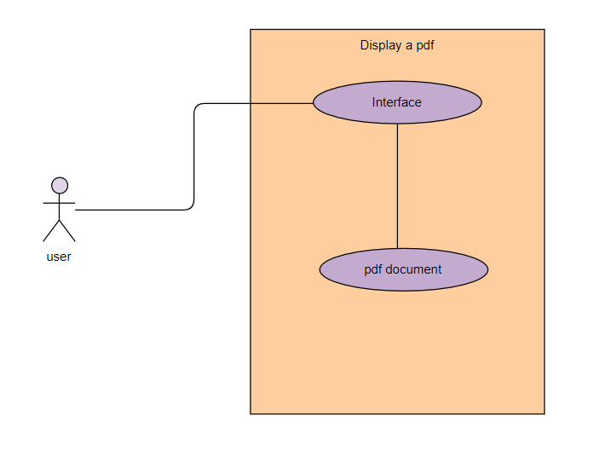

1. **Highlighting a Sentence:**

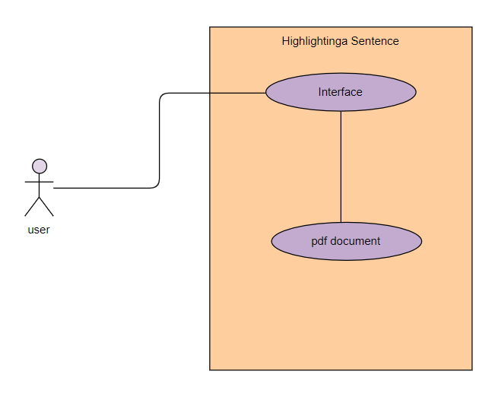

1. **Jumping to the desired page:**

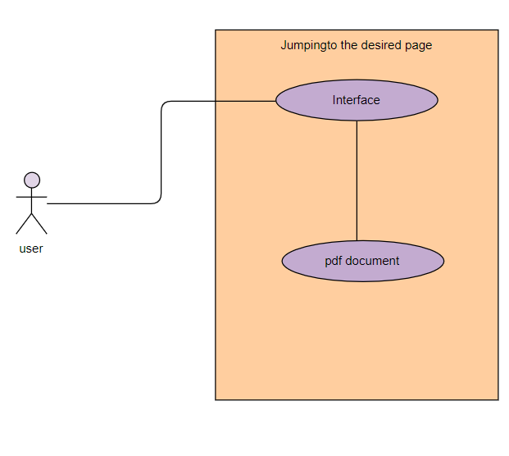

**Activity Diagram:**

1. **Displaying a pdf document:**

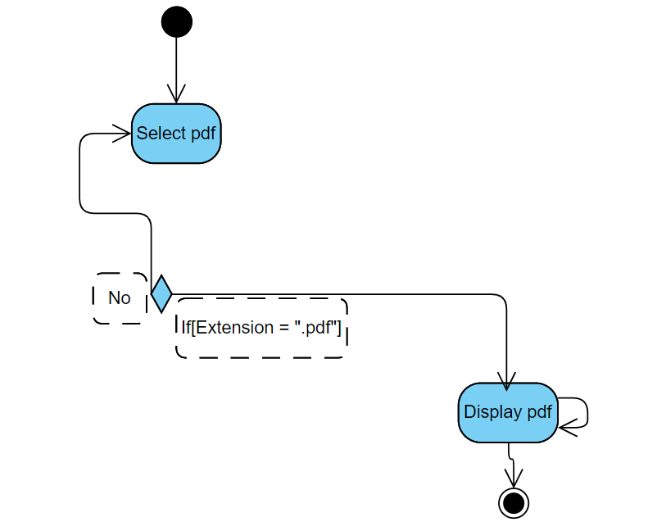

1. **Highlighting a sentence:**

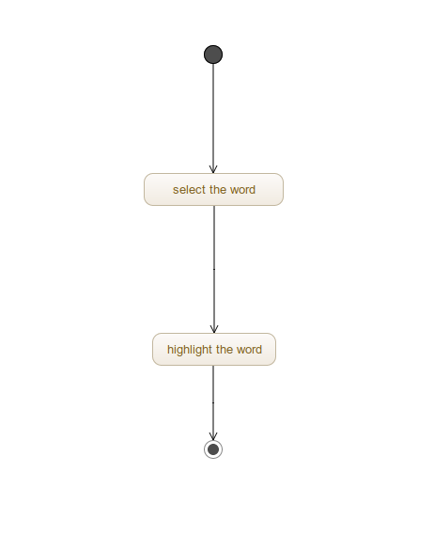

1. **Jump to the Desired Page:**

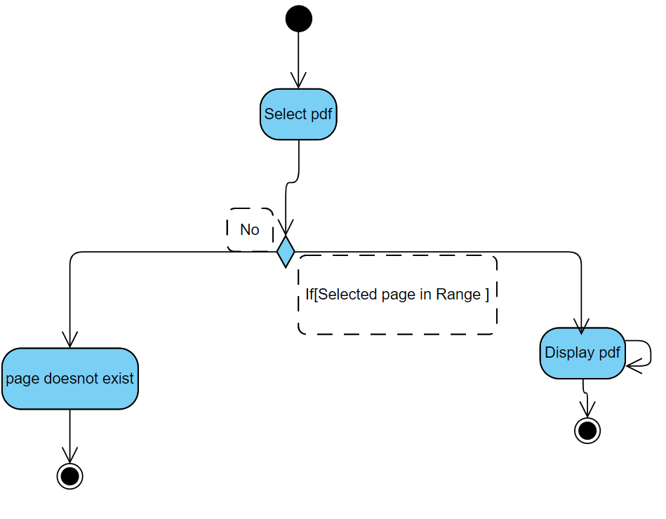

**Domain Model:-**

1. **Displaying a pdf document:**

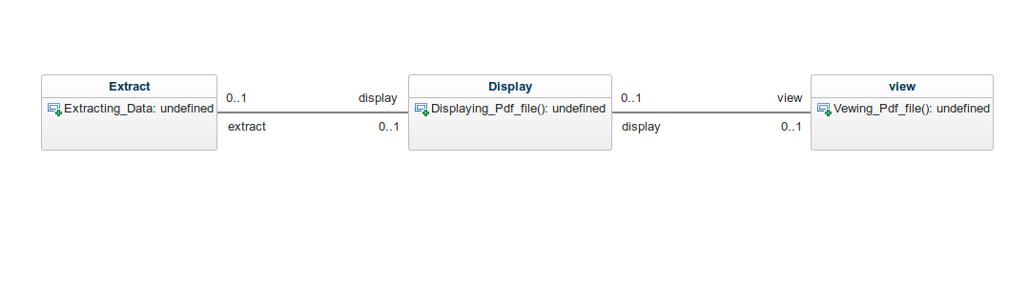

1. **Highlighting a sentence:**

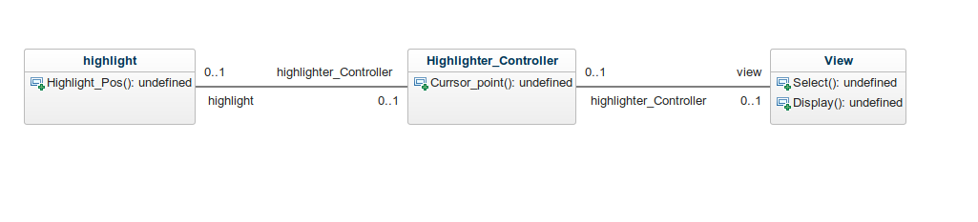

1. **Jumping to desired page:**

